SPONSORSHIP FORM

Thank you for sponsoring Equinox Gold’s Ride to Greenstone! Together, we’ll make the opening of the Greenstone Mine an unforgettable achievement for the community of Geraldton and the surrounding region, our Indigenous partners, our business partners and supporters, and the Canadian mining industry!

Please fill out this form and send the requested information to Ride2Greenstone@equinoxgold.com.

Company Name
Primary Contact Name
Contact Email
Contact Phone

As a “thank you!” for your sponsorship, your company will receive branding and marketing opportunities commensurate with your level of support. You can choose to participate in three different ways: cash donation to Geraldton District Hospital, in-kind donation to support the logistics of the cycling event, in-kind with an additional cash donation to Geraldton District Hospital. Please see the following page for more information about the sponsorship levels and then indicate your level of sponsorship below.

We would like to sponsor Ride to Greenstone at the |  |  |  |  | level with our sponsorship divided as:
Cash C$ |  | In-kind product/services valued at C$ |  |  |  | Total C$

Please send your cash sponsorship directly to Geraldton District Hospital so you can get a tax receipt. Our Ride to Greenstone website includes instructions to donate by cheque, credit card or wire transfer.

To increase donations to Geraldton District Hospital, we’ll try to get as much media and community awareness as possible and will ask your communications department to do a few social media posts about your company’s involvement with the event. Please put us in touch with the most appropriate person on your team.

Communications Contact Name
Contact Email
Contact Phone

Thank you so much for your support! If you have any questions or concerns, please contact Rhylin Bailie, Equinox Gold’s VP Investor Relations, by phone at 604-260-0516 or by email at Ride2Greenstone@equinoxgold.com.

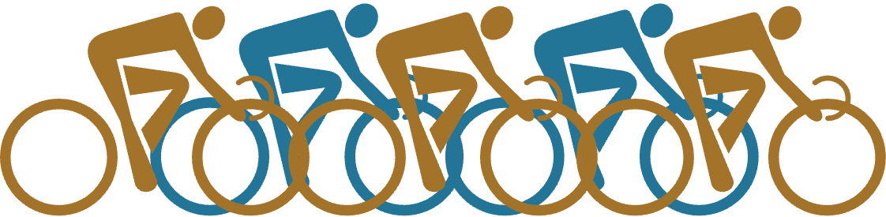

Your sponsorship level will be determined by adding together:
- The amount of your cash donation to Geraldton District Hospital
- The approximate dollar value of your in-kind product or services

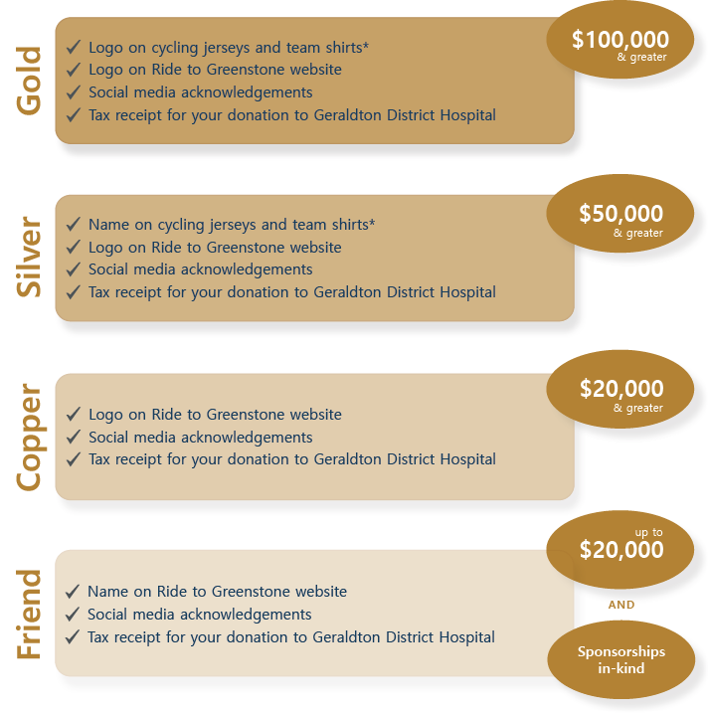

* Sponsorship form must be received by May 31st to have your company included on team clothing.

Please send your cash sponsorship directly to Geraldton District Hospital so you can get a tax receipt.
Our Ride to Greenstone website includes instructions to donate by cheque, credit card or wire transfer.

